**Smart Waste Management System For Metropolitan Cities**

**Abstract**

Medical waste disposal has been a big issue due to an exponentially growing population and the COVID-19 pandemic. Increased waste generation per person has resulted from urbanization, industrialization, and economic development. Substandard medical waste separation at the site of origin might have a cascading effect on the environment, putting humans, wildlife, and soil and water bodies at danger. If hazardous airborne pollutants are not effectively controlled, separated, and burned by on-site or off-site incineration, environmental concerns linked with inadequate clinical waste may pollute the air we breathe. This paper proposes an IoT based smart health care waste segregator which segregates the waste into five kinds. The sensors detect and the type of waste and the waste gets disposed into the smart bins accordingly. Using artificial intelligence, the status of filling of the bin is indicated through LED’s. When the bin reaches the maximum-level an alert message is sent to the municipal authorities. The filled waste gets wrapped automatically. The wastes which need to be incinerated are burnt in the incinerator chamber available in the system. Therefore, this system will capably make the environment smart, clean and safe.

**Keywords:** Sensors, IoT, artificial intelligence, incinerator, garbage, smart bins

1. **Introduction**

The Internet plays an important role in today' world by linking computers to the planet Wide net (www), that permits users to access data from everywhere the world [1]. The Internet of Things (IoT)refers to things that are connected to the internet and can often be managed from there[2]. Garbage is described as solid substances generated as a result of human activities that are removed from the system[3] because they are no longer useful in the respective economic, biomedical, or technical method. In a wider context, solid waste refers to all products that are used in the home, industry, or agriculture. Municipal solid waste (MSM) is described as waste that accrues in areas maintained by municipalities that are responsible for its disposal and recycling. People can throw garbage in waste bins, which is why they are valuable in life[3]. If it didn't happen, the future would be a mess. Because a business or household has a garbage disposal device, it becomes a valuable piece of equipment. The dustbin's position as a conciliator of changing waste practices has barely been regarded, despite its importance in our daily lives. Bins, it is believed, are providing a telling indicator of new garbage relationships in society as they are repurposed as environmental technologies for modern recycling schemes. Garbage, garbage, and litter are all over the television these days, with disturbing statistics of debris filling the world. Despite the grim news, a number of people and policymakers are trying to change the trend by creative waste management practises. The Government has encouraged city-based schemes and public-private collaboration projects to improve waste management systems, but these have proven to be troublesome. The shortage of financial capital, sufficient expertise, and technical competencies in the public sector are the main obstacles to developing solid waste management systems around the world. Governments have begun to look at PPPs as a possible solution. The amount of change and development made was minimal. Medical waste management is tough and complicated, especially during pandemics like COVID. Due to the apparent forte of the global outbreak, adapting contemporary waste centers to reveal the abnormal scientific waste and its affect on viral propagation want particular statistics on the amount of scientific waste generated, waste warm spot and remedy centers. Multiple technological know-how( Sarkodie & Owusu, 2020) on inspection, segregation, transportation, storage, and reliable waste control structures are required to optimize contemporary sources and centers to satisfy the crisis, as healthcare waste portions are anticipated to upward push rapidly.In patient, health care workers, and waste collectors, improper medical waste disposal can lead to accidents, diseases, harmful consequences, and air pollution. Bio-dangerous cloth and its opposite numbers encompass non-dangerous waste, infectious waste, radioactive waste, bacterial waste, chemical waste, cytotoxic waste, sharps waste, and pharmaceutical trash.

A pandemic has identified an unusual amount of medical waste. As a result of this research, some serious problems were discovered and some important suggestions were made. To prevent the spread of any dangerous diseases, a proper waste management system is needed. This paper proposes a waste management strategy that is both effective and successful. This garbage show is made with sensors and an Arduino microcontroller. The suggested scheme satisfies the need for continuous garbage material tests in the bins. It aids in the disposal of garbage until the bins become overflowing. As a result, the device is helpful in waste management when it is monitored and informed on a daily basis. This translates to a cleaner city and a higher quality of life.

1. **Related Works**

Garbage, garbage, and litter are all over the television these days, with disturbing statistics of debris filling the world. Despite the grim news, a number of people and policymakers are trying to change the trend by creative waste management practices. These five forward-thinking countries are taking a novel approach to waste management in order to make the environment a safer, healthier place. Germany is first, followed by Austria, South Korea, Wales, and Indonesia. Clean Harbors, Stericycle Inc., Covanta Holding, and others are among the best waste management firms in the world.

The Government of India has encouraged city-based schemes and public-private collaboration projects to improve waste management systems, but these have proven to be troublesome. The lack of financial resources, appropriate skills, and technological competencies with the public sector are the main obstacles to improving solid waste management services in India. Governments have begun to look at PPPs as a possible solution. The amount of change and development made was minimal. Some serious problems have been discovered as a result of this research, and some significant proposals have been made.

This article [4]Present a system (hardware, software, and communications) to improve trash handling while also involving citizens. The model employs an IoT method in which the discharged trash from the trash container is continuously monitored by sensors that provide real-time information upon those filling levels of each chamber. An IoT-based smart trash system [5](SGS) is presented in this study to decrease food waste. Wireless mesh networks enable battery-powered smart trash bins (SGBs) to interact with one another in an SGS, while a router and server collect and analyse data for application services.[6]Suggested a unique approach for achieving waste management that is both vigorous and efficient by forecasting the likelihood of waste levels in trash bins in this article. Combining machine learning and graph theory, the system can optimise trash collection via the shortest path. This article describes an investigative case that was carried out on the Ton Duc Thang University (Vietnam) campus to assess the system's performance and viability. A cross-domain robust distributed trust management [7](Robust Trust) system is suggested in this work, that also making a system suitable for independently evaluating faith towards various devices. The credibility in this approach is split into three security technologies that enable IoT nodes be resilient against hacked and malicious devices/nodes. This study [8]proposes a strategy for achieving this ambitious goal. In this article, a microcontroller is used to interface an ultrasonic sensor and GSM modem to construct an intelligent container. The highest point of the trashcan is fitted with an ultrasonic sensor, which measures the dustbin's height.

[9]Proposed a novel waste disposal based on an Android mobile app and a Bluetooth-enabled smart dustbin in this article. Through the lines painted on the floor, this android application controlled the bot. The lines are usually specified along the path. A white line on a black surface or vice versa might be one of the predetermined routes. In this study[10], a novel architecture is suggested with the goal of improving waste disposal on-site handling and transfer optimization. The network is based on a sensor network, and Data Transfer Nodes (DTN) are used to communicate data from garbage bin filling to a remote server.

[4]This article presents a system (hardware, software, and communications) to improve trash management while also involving citizens. The system uses an IoT method in which the discarded trash from the smart bin is continually monitored by sensors that provide real-time information on the filling level of each compartment.[11] This article proposes a revolutionary sensor node design based on the use of low-cost, high-efficiency components such as water level, soil moisture, temperature, humidity, and rain sensors. The transmitting module, in particular, is based on the LoRa LPWAN method, ensuring overall system performance. The principal circuit board of the system is optimised by combining two layers and doing code optimization.

[12]The concept of a garbage surveillance system for smart campuses, colleges, clinics, and bus stops is proposed in this article. The Garbage Monitoring System is a clever dustbin that makes use of sensors to raise it above the trendy dustbin.[13]In the proposed system, public trash cans would be equipped with an integrated device that allows for real-time tracking of waste levels in the bins. The information on waste levels would be used to create an optimal path for trash collection vans, which will save money on fuel. The load sensors will enhance the accuracy of trash level information, while humidity sensors would give data on waste segregation in a dust bin.

[14]The suggested model, which employs a convolutional neural network (CNN), a prominent machine learning approach, to separate biodegradable and insoluble waste, is presented un this study. The plan also includes an architectural concept for a smart garbage can that incorporates a microprocessor and several sensors.[15]They presented an Internet of Things-based management of solid waste in this article, which allows garbage bin monitoring, dynamic scheduling, and tracking of garbage collector vehicles in a city of the future. Garbage bins fitted with moderate embedded devices are placed around the city under the proposed model.

[16]To combat COVID-19, this study suggests a leader-follower strategy for hazardous infectious waste collection and government aid distribution. We suggest a smart waste material classification based on the 50-layer residual net pre-train (ResNet-50) Convolutional Neural Network model, which would be a machine learning tool as well as represents as the extractor, and indeed the Support Vector Machine (SVM), that is used to categorize waste into useful groups/types including glass, metal, paper, and plastic, among others as proposed by[17][18] suggested the “Smart Dustbin” in this article, which would be a Cellular bin that autonomously monitors rubbish levels and transmits messages to the appropriate city officials to update the bin's status.[19]This article discusses an automated system that allows depositors to dispose of their e-waste and be compensated for it. In terms of e-waste collectors, an online bidding session is held, with the winner receiving ownership of the electronic trash that he or she won in the online bidding process. For this, an interactive digital bin with multiple sensors and modules is required. After user verification, the bin must be able to lock and unlock itself.(Urlagunta) The smart bin in this article is based on the Micro - controller system, which is connected to a GSM modem and also an ultrasonic sensor. An ultrasonic sensor is mounted on the top of the trashcan to measure the dustbin's height. The minimum height is set at 10cm. The Microcontroller will be designed such that when the trash fills, the remaining height above the threshold height will be shown

[20]This paper describes the design and implementation of an internet of things (IoT) based Arduino microcontroller that uses ultrasonic sensors are used to detect the amount of trash in garbage bins and reveal the information and updates as "empty," "half-filled," or "filled" on an LCD screen at periodic intervals, and also transmit the data level information. [21] An Internet of Things (IoT) architecture for real-time garbage monitoring and collection is presented in this study, with the goal of improving and optimizing solid waste collection in cities. The Netlogo Multi-agent platform was used to mimic real-time monitoring and intelligent waste management decisions.

[22] An automatic trash segregator is proposed in this study. When medical waste is detected, the conveyor belt is moved by an external motor. The trash will be sent to the sensing and classification units. The input picture is captured, pre-processed, Median filtering, contrast enhancement, and segmentation are all done in five phases. [23] The article creates the ‘Waste Hierarchy-Technology Readiness Levels' framework and evaluates each waste management plan against it, showing the technological maturation and the strategy's place in the Waste Framework directive, as well as its relative adherence to circular economy concepts. [3] This article presents a concept for a smart garbage bins surveillance system in Ethiopian cities that uses the Global System for Mobile Communication (GSM) to organize trash collection networks in residential and commercial sectors. The level of waste material in the trash bin has been monitored using an ultrasonic sensor in this suggested system, and it will continually connect with the authorized clean-up person's cell phone via GSM modem.

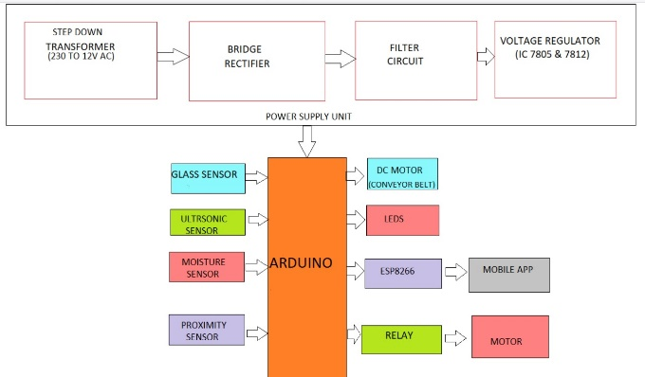This research will be crucial not only for individuals whose professions primarily entail the disposal of garbage cans, but also for the general public who will be following the smart city rules for a higher quality of life. The implementation of this suggested technique would go a long way forward into ensuring effective and efficient real-time garbage disposal and resource utilization, as well as improving life for smart city residents. The actual implementation of the functional conceptual model will serve as an advanced as well as instructive technique of sustaining and improving the wellbeing of smart urban residents with in long run.

1. **System Architecture**

Figure (i) illustrate the overall system architecture module. Inlet, Split rollers, Pipeline system, Dihydrogen monoxide outlet system exhaust System, Chained

**Fig. 1** System Architecture

conveyor belt, Incinerator, Solar panel, Brushes, Arduino Uno microcontroller, IR Sensor, Ultrasonic Sensor, Moisture Sensor, Glass Detector sensor, Inductive proximity Sensor, Node-MCU ESP8266, Wrapper,3 chambers for dihydrogen monoxide-2 for contaminant dihydrogen monoxide 1 for pristine dihydrogen monoxide, Thermo engenderer and Electrodes, ECU board, Breadboards, Jumper wires, OLED Exhibit, LED lights, DC motor is the few main components utilized for making the module.

If medical waste is disposed of in the inlet, it is transferred to the chain conveyor belt, which triggers the DC motor which causes the conveyor belt to move. Metal, dry, wet, glass, and incinerate wastes are dissevered into five categories. The sensors detect the waste predicated on the type of waste, and the waste is then sorted into concrete bins. The state of filling the bin is immediately signaled by LEDs utilizing artificial perspicacity. The red LED on the bin commences flashing as it approaches full capacity, and a caveat note is sent to the local ascendant entities. The waste that has been filed is immediately bundled. The wastes that must be incinerated are burned in the contrivance's incinerator chamber. The thermo-engenderer converts the heat engendered in the incinerator chamber into electrical energy. The conveyor belt's DC motor consumes the engendered electrical energy. The conveyor belt is automatically washed until the whole operation is consummated utilizing a chain conveyor belt cleaning machine.

IoT, AI, and web/app Development are the three innovations utilized in this scheme. To control the flow of waste into the conveyor, the inlet segment has an open and close function. To detect metallic waste, an inductive proximity sensor is utilized. Arduino Uno is in charge of the conveyor belt's pacing and rotation. An incinerator is additionally part of this contrivance. When a human pushes the trigger, the controls are turned off, and the waste on the conveyor belt is sent to the incinerator container. The walls of the incinerator are composed of clay and covered with aluminum foil. Inside the incinerator are the ECU board electrodes and thermo-engenderer, which are habituated to engender electricity from thermal energy. The DC motor is driven by the engendered electricity. The sensors are deactivated until the procedure is done. This contrivance withal has the capability of sending an admonishment SMS if a bin is loaded. Action is detected by an infrared sensor. Moisture Sensors for dry and wet waste, Inductive Proximity Sensors for metal waste, Ultrasonic Sensors for bin filling tracking Warning messaging via Node MCU ESP8266-12E, visual exhibit via OLED Exhibit, and waste packaging via hotwire sealer.

The Biomedical Waste Segregator is a piece of automated machinery that sorts waste into four categories: metal, glass, dry, and wet. The suggested framework would be capable of monitoring and managing the solid waste amassment process as well as the total amassment process. To detect metallic waste, an inductive proximity sensor is utilized. Dry and wet waste is disunited utilizing a blower system. A microcontroller controls the timing and rotation of the conveyor belt. This contrivance additionally has a feature that sends an admonition SMS if a bin is loaded.

**3.1 Wrapping:**

The Ultrasonic sensor causes the door of the respective container to close as the waste is filled in it. The container's door is made up of two semi-circular panels. One of the circular plates is connected to the other by a thin rod, while the other is connected by an insulating rod (namely wood). A very low volt current is passing through each rod as the doors close. The rods (the rod with electric flow heats up) come next to each other until the door is fully locked. The heat and compression are just enough to melt and seal the trash container. Once the doors of the container are closed, the current in the rod flows till the rod reaches enough temperature.

**3.2 Incinerator:**

To burn the garbage, an incinerator is required. Medical waste must be incinerated in some cases. When a human pushes the trigger, the controls are turned off, and the waste on the conveyor belt is sent to the incinerator container. The walls of the incinerator are made of clay and covered with aluminum foils. Inside the incinerator are the ECU board electrodes and the thermo generator, which is used to generate electricity from thermal energy. The DC motor is driven by the produced electricity.

**3.3 Conveyor cleaning system:**

The conveyor cleaner makes contact with the returned conveyor and uses a rotating, pre-moistened, heavy-duty belt to scrub it continuously. For ease of product handling, the clean conveying surface is allowed to dry.Conveyor cleaners are made of heavy-duty stainless steel and have long-lasting scrubbing belts that need no maintenance. A 1/4inch NTT-thread is used to connect to the water inlet, and a manual shutoff is included. A three-quarter inch ID hose is used to empty the drain pan. The belt friction corrections, as well as the drain tub, are also conveniently accessible for normal maintenance.The CC series of conveyor cleaners are enticing solutions for reduced tension line downtime because of these characteristics, as well as ease of operation and easy insulation.

**3.4 Circuit diagram:**

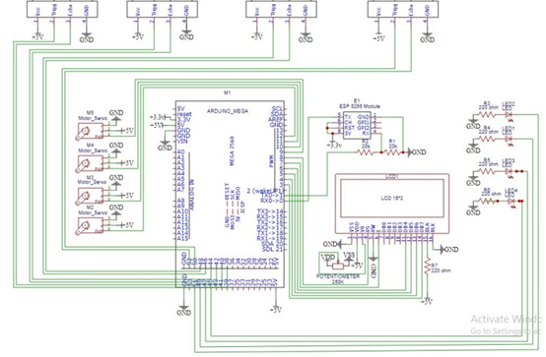

**Fig.2** Circuit Diagram

In the above circuit diagram, On the left most side ultrasonic sensor is connected trigg pin = 38 (output) and echo = 40(input). On the left 2nd one ultrasonic sensor is connected trigg pin = 42 (output)and echo = 44(input). On the 3rd ultrasonic sensor is connected trigg pin = 46 (output)and echo = 48(input). On the right most side ultrasonic sensor is connected trigg pin = 52 (output)and echo = 50(input). M2, M3, M4, M5, are servo motors. At M2, pwm=12. At M3, pwm=11. At M4, pwm=10. At M5, pwm=9. LED 2=51 LED 1 =49 LED 3 = 47 LED 4 =45. We use esp 8266. So, the tx is connected to rx 0. And the rx is connected to tx 0. Then the other pin of the 16 *2 LED display.

**3.5 Optimal Path Planning Algorithm for Waste Collection:**

Step 1: Set up the microcontroller and all of the sensors.

Step 2: Switch on the ESP8266 and initialise the SIM.

Step 3: When Wi-Fi is open, the mobile device connects to the network using an IP address.

Step 4: When the height and weight of the bins exceed the margin, an SMS message is sent.

Step 5: Using the IP Address on the HTML tab, you can check the status of the bins.

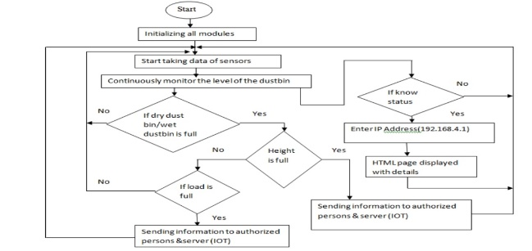

**Fig. 3** Optimal Path Planning Algorithm

**6. Methodology**

The conveyor belt motor engages as the waste arrives, and the conveyor belt commences to move. Many of the motors and controls, as well as the microcontroller, have been switched on. With a significantly extending people and in this Covid pandemic, it is extensively more basic to be benevolent concerning how well we, individuals, manage our prosperity and environment. Considering the insights, it is seen that authentic clinical trash evacuation is especially expected for a spotless environment. The modernized waste segregator is a capable and monetary waste combination structure with a base proportion of human mediation and besides makes no risk human life. Using a vehicle line makes the system significantly more accurate, monetarily canny, and besides clearer to put in and use at a local level. Segregating these misfortunes at a local level in like manner will be timesaving. The proposed structure fulfils the requirement for reliable watches out for garbage content in the containers.It helps with disposing of the waste material before it floods from the canisters. So standard noticing and recommending make the structure significant in waste the board. This prompts an immaculate city for better living.

If the trash isn't metallic, the conveyer belt sensor decides if it's a wet or dry waste by estimating the dampness content of the waste. If there is moisture in the waste, it is classified as wet waste, and the conveyor belt is switched off, the wet waste motor is turned on, and the garbage is deposited in the wet waste container. Counter 2 is also increased. If the conveyor belt is not carrying any wet trash, the waste is deposited into the dry waste bin at the top of the conveyor belt. When a waste containing glass particles is identified as glass waste, the ergo conveyor belt is turned off, the glass waste motor is turned on, and the garbage is forced into the glass waste bin. In consequence, the counter 3 is raised.

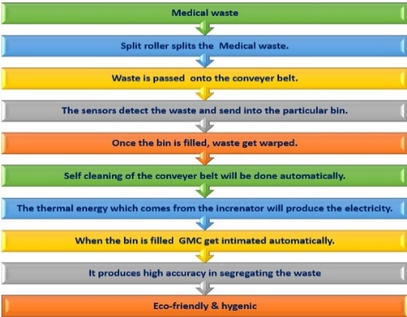 Conclusively, the wastes are deposited in the congruous containers, consummating the segregation process. When the dustbin level reaches 50% the yellow led which is annexed to the bins gets turned on. If 75%, green led gets turned on. If 90%, the red led commences blinking, and if 100%, the red led gets turned on, and then the SMS alert will be activated. When the bin gets filled, by utilizing the wrapper the waste gets wrapped automatically. This system withal has a self-cleaning system of a conveyor belt. The conveyor chain enters the conveyor cleaner and being engaged by the hold-down bracket. The hold-down bracket guarantees that the chain makes full contact with the scrubbing belt, which rotates in the antithesis direction. The conveyor chain is squeegeed by a spring-loaded neoprene blade as it exits the conveyor cleaner afore being returned to the conveyor line. The conveyor belt is swept in this manner.

**Fig. 4** Flow diagram of Overall process

**7. Mobile App**

This app is about detecting the amount of waste in each bin.First, we need to select the state, district and area.Using this information it displays the number of bins present in that area and the amont of waste in them.As said,LED's are used for easy identification of amount of waste.If it is of red color ,it indicates that the bin is completely filled and need to be cleaned.If it is yellow,the bin is partially filled and if it is green ,it is empty.This information is sent to the nearest municipal corporations.So that the waste disposal becomes easy.

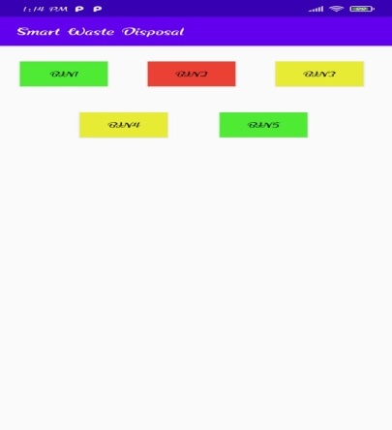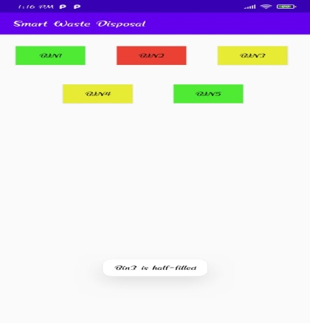

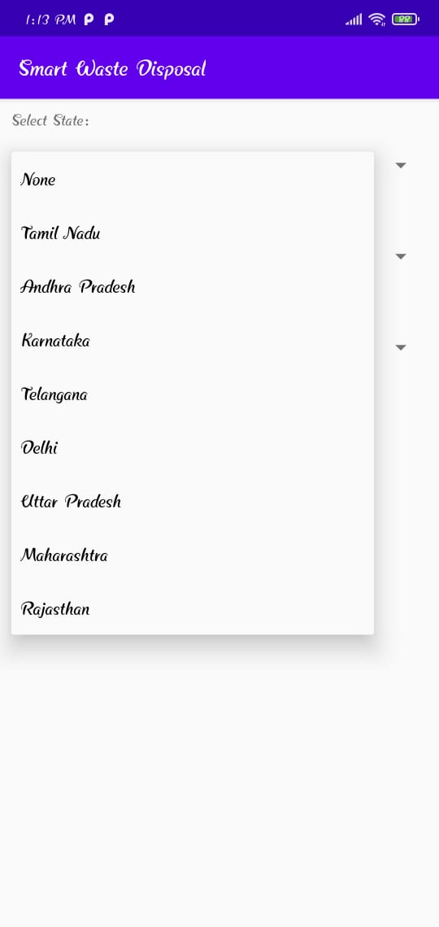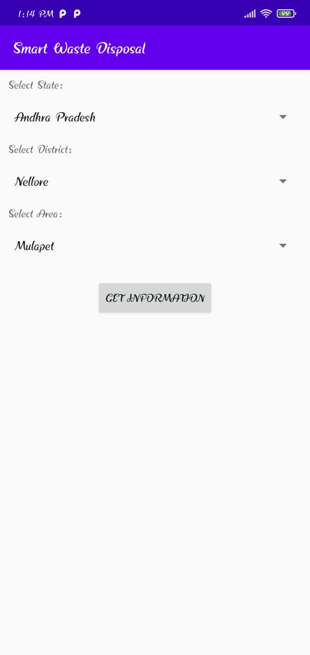

**Fig. 5** Web Page Inerface to display the status of the smart bins

**8. Conclusions and Future Works:**

With a dramatically expanding populace and in this Coronavirus pandemic, it is considerably more critical to be kind with regards to how well we, the people, deal with our wellbeing and climate. In view of the perceptions, it is perceived that legitimate clinical garbage removal is particularly required for a clean climate. The computerized squander segregator is a proficient and financial waste assortment framework with a base measure of human intercession and furthermore makes no peril human existence. Utilizing a transport line makes the framework substantially more exact, financially savvy, and furthermore more straightforward to place in and use at a homegrown level. Isolating these losses at a homegrown level likewise will be timesaving. The proposed framework satisfies the need for consistent keeps an eye on trash content in the receptacles. It assists with discarding the waste material before it floods from the canisters. So, standard observing and suggesting make the framework valuable in squander the board. This prompts a spotless city for better living.

The automatic waste segregator is a cost-efficacious and reliable waste accumulation contrivance that requires no human involution and poses little risk to human safety. The utilization of a conveyor belt ameliorates the precision, cost-efficacy, and facilitate of installation and utilization of the system on a domestic substructure. Dissevering these wastes at the household level would withal preserve time. The suggested scheme slakes the desideratum for perpetual monitoring of the medical waste material in the bins. It avails in the disposal of garbage until the bins become overflowing. This translates to a cleaner city and a higher standard of living.

Restorative treatment is basic to our survival and supportability. Incomprehensible restorative squander isolation at the point of inchoation may have a domino impact on the environment, posturing dangers to people, natural life, and soil and dihydrogen monoxide bodies. Natural dangers related with destitute healthcare squander administration may sully the discuss we breathe by poisonous airborne contaminants in the event that they are not satisfactorily contained, isolated, and burned by on-site or off-site burning. As a result, such squander needs uncommon care and support afore being arranged of. It is vital that healthcare laborers get it the esteem of therapeutic squander control.

**Nomenclature**

|  |  |
| --- | --- |
| LED | Light Emitting Diode |
| WWW | World Wide Web |
| MSW | Municipal Solid Waste |
| PPP | Public Private Partnership |
| DTN | Data Transfer Nodes |
| SGB | Smart Garbage Bins |
| LoRa LPWAN | Long Range Low Power Wide Area Networks |
| GSM | Global System for Mobile |
| CNN | Convolutional Neural Networks |
| IoT | Internet of Things |
| IR | Infra-Red |
| ECU | Electronic Control Unit |

**Declarations**

**Availability of data and materials**

Information accessibility isn't appropriate to this composition as no unused information were made or analyzed in this ponder.

**Competing interests**

The Author(s) declare(s) that there is no conflict of interest.

**Funding**

This work is partially funded by Centre for System design, Chennai Institute of Technology vide funding number CIT/CMR/2021/006.

**Author’s Contribution**

All the authors contributed indistinguishablyto the work. All authors examined and endorsed the ultimate composition.

**Acknowledgement**

The authors acknowledge the Centre for System design, Chennai Institute of Technology for carrying out the research.

**References:**

[1] B. Bharadwaj, M. Kumudha, N. Gowri Chandra, G. Chaithra, Automation of Smart waste management using IoT to support “Swachh Bharat Abhiyan” - A practical approach, Proc. 2017 2nd Int. Conf. Comput. Commun. Technol. ICCCT 2017. (2017) 318–320. https://doi.org/10.1109/ICCCT2.2017.7972300.

[2] A. Sharma, R. Kumar, V. Mansotra, Proposed Stemming Algorithm for Hindi Information Retrieval, Int. J. Innov. Res. Comput. Commun. Eng. (An ISO Certif. Organ. 3297 (2016) 11449–11455. https://doi.org/10.15680/IJIRCCE.2016.

[3] M. Karthikeyan, D. Eligo, S. Gebrehiyot, E. Bekele, D. Daniel, G. Dansa, GSM Based Smart Waste Bin Monitoring System In Ethiopia, VI (2019) 796–804.

[4] K. Pardini, J.J.P.C. Rodrigues, O. Diallo, A.K. Das, V.H.C. de Albuquerque, S.A. Kozlov, A smart waste management solution geared towards citizens, Sensors (Switzerland). 20 (2020) 1–15. https://doi.org/10.3390/s20082380.

[5] I. Hong, S. Park, B. Lee, J. Lee, D. Jeong, S. Park, IoT-Based Smart Garbage System for Efficient Food Waste Management, Sci. World J. 2014 (2014). https://doi.org/10.1155/2014/646953.

[6] T. Anh Khoa, C.H. Phuc, P.D. Lam, L.M.B. Nhu, N.M. Trong, N.T.H. Phuong, N. Van Dung, N. Tan-Y, H.N. Nguyen, D.N.M. Duc, Waste Management System Using IoT-Based Machine Learning in University, Wirel. Commun. Mob. Comput. 2020 (2020). https://doi.org/10.1155/2020/6138637.

[7] K.A. Awan, I. Ud Din, A. Almogren, M. Guizani, A. Altameem, S.U. Jadoon, RobustTrust - A Pro-Privacy Robust Distributed Trust Management Mechanism for Internet of Things, IEEE Access. 7 (2019) 62095–62106. https://doi.org/10.1109/ACCESS.2019.2916340.

[8] V.P. Vijaynaidu, T. Dhikhi, Smart garbage management system, Int. J. Pharm. Technol. 8 (2016) 21204–21211. https://doi.org/10.17577/ijertv4is031175.

[9] C.S. Anilkumar, G. Suhas, S. Sushma, A smart dustbin using mobile application, Int. J. Innov. Technol. Explor. Eng. 8 (2019) 3964–3967. https://doi.org/10.35940/ijitee.K2129.0981119.

[10] S. Longhi, D. Marzioni, E. Alidori, G. Di Buò, M. Prist, M. Grisostomi, M. Pirro, Solid waste management architecture using wireless sensor network technology, 2012 5th Int. Conf. New Technol. Mobil. Secur. - Proc. NTMS 2012 Conf. Work. (2012). https://doi.org/10.1109/NTMS.2012.6208764.

[11] T.A. Khoa, M.M. Man, T.Y. Nguyen, V.D. Nguyen, N.H. Nam, Smart agriculture using IoT multi-sensors: A novel watering management system, J. Sens. Actuator Networks. 8 (2019). https://doi.org/10.3390/jsan8030045.

[12] R. Asha, N. Mahajan, A. Yadav, K.S. Balamurugan, Garbage Managing Smart System using-IOT, Int. J. Recent Technol. Eng. 8 (2019) 3646–3649. https://doi.org/10.35940/ijrte.d7849.118419.

[13] P.S.A. Mahajan, A. Kokane, A. Shewale, M. Shinde, S. Ingale, Smart Waste Management System using IoT, Int. J. Adv. Eng. Res. Sci. 4 (2017) 93–95. https://doi.org/10.22161/ijaers.4.4.12.

[14] M.W. Rahman, R. Islam, A. Hasan, N.I. Bithi, M.M. Hasan, M.M. Rahman, Intelligent waste management system using deep learning with IoT, J. King Saud Univ. - Comput. Inf. Sci. (2020). https://doi.org/10.1016/j.jksuci.2020.08.016.

[15] S.S. Chaudhari, V.Y. Bhole, Solid Waste Collection as a Service using IoT-Solution for Smart Cities, 2018 Int. Conf. Smart City Emerg. Technol. ICSCET 2018. (2018) 1–5. https://doi.org/10.1109/ICSCET.2018.8537326.

[16] J. Valizadeh, A. Hafezalkotob, S.M. Seyed Alizadeh, P. Mozafari, Hazardous infectious waste collection and government aid distribution during COVID-19: A robust mathematical leader-follower model approach, Sustain. Cities Soc. 69 (2021) 102814. https://doi.org/10.1016/j.scs.2021.102814.

[17] O. Adedeji, Z. Wang, Intelligent waste classification system using deep learning convolutional neural network, Procedia Manuf. 35 (2019) 607–612. https://doi.org/10.1016/j.promfg.2019.05.086.

[18] P. Proposal, U. Unnat, B. Abhiyan, Smart Dustbin, (n.d.).

[19] K.B. Kumar R, S.B. Patil, S. Manjula, H.N. Kumar, An IoT Based Approach for Efficient Collection and Disposal of E-waste, Int. J. Eng. Tech. 4 (2018) 379–383.

[20] S. Abba, C. Light, IoT-Based Framework For Smart Waste Monitoring And Control System, A Case Study of Smart Cities., (2020) 8224. https://doi.org/10.3390/ecsa-7-08224.

[21] E.D. Likotiko, D. Nyambo, J. Mwangoka, M Ulti -a Gent B Ased I Ot S Mart W Aste M Onitoring a Nd C Ollection, Ijcseit. 7 (2017) 1–14.

[22] K.G. Devi, K. Yasoda, M. Dhivya, B. Kishore, Automatic Health Care Waste Segregation and Disposal System, J. Xidian Univ. 14 (2020) 5281–5290. https://doi.org/10.37896/jxu14.5/573.

[23] C.A. Fletcher, R. St. Clair, M. Sharmina, A framework for assessing the circularity and technological maturity of plastic waste management strategies in hospitals, J. Clean. Prod. 306 (2021) 127169. https://doi.org/10.1016/j.jclepro.2021.127169.